**UX DESIGN: 4 IDEATION**

**Welcome**



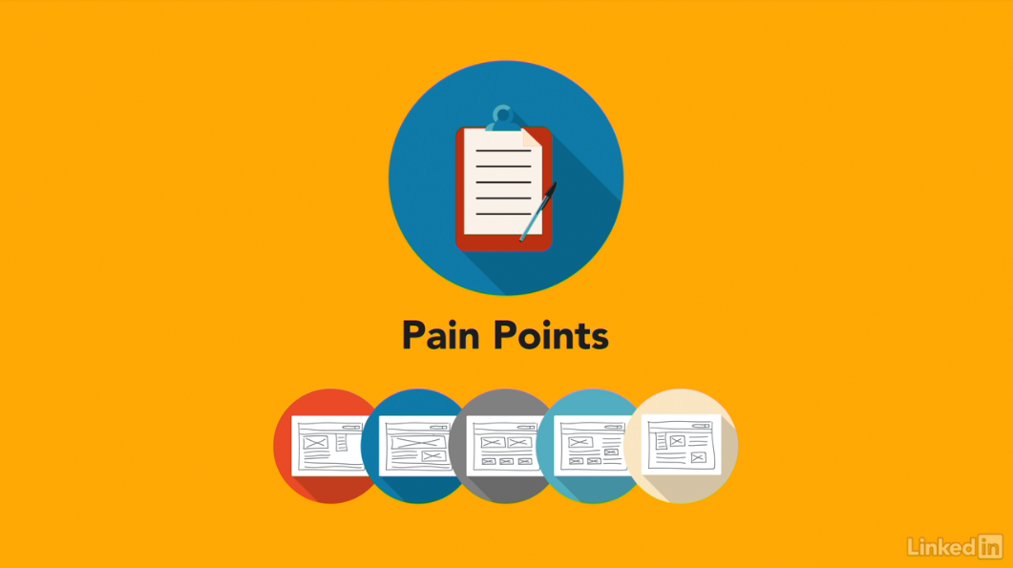

[Hello, I'm Chris Nodder. Welcome to the fourth episode of the UX Design Techniques series. In this episode, we'll discuss ideation techniques. That is, ways to find creative solutions to your interface issues. This is the fourth course in a series that describes a set of techniques you can use to make your development process more user-centered. In this installment, I'll show you how to generate multiple creative ideas for fixing the user pain points you uncovered in earlier stages of the process. Ideation is a technique that lets you explore lots of different design ideas in a very short space of time, drawing on the diverse ideas that each member of the team can bring to the table. Having a broad set of ideas to draw from makes it much more likely that you'll come up with a suitable solution. Now it's time to dive in and learn about ideation techniques that you can use to unleash the creativity of your team and explore many potential ways forward for your product. So let's get started.](https://www.linkedin.com/learning/ux-design-4-ideation/welcome?resume=false)

1. **Adding Creativity to the User-Centered Design Process**

**What does ideation mean?**

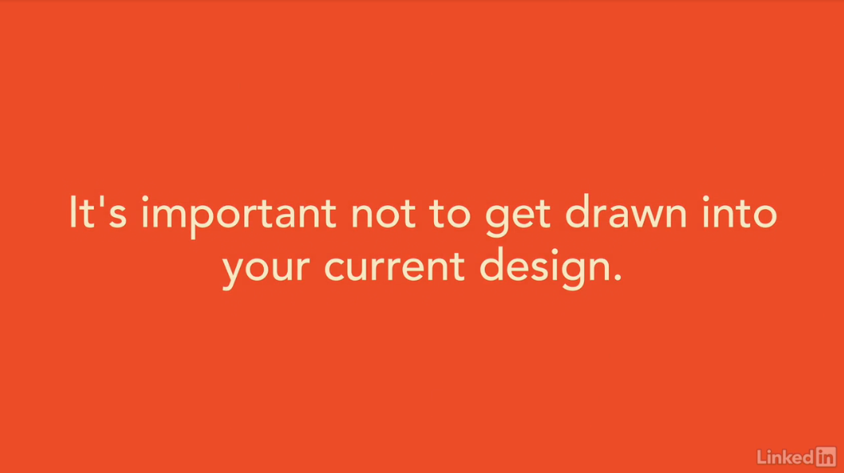

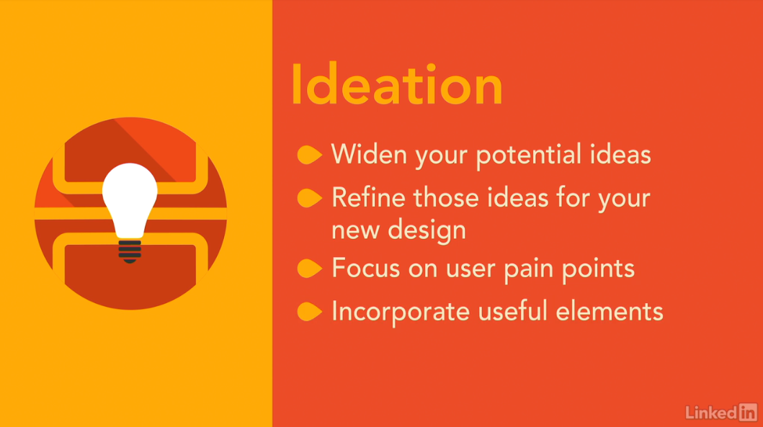

[When you have an idea about how something should be, it's hard to get that idea out of your mind and explore alternatives. It's a bit like having a song stuck in your head. Even if the song's a good one, it's likely that you don't want to keep listening to it forever. Instead, you probably want some variety. It's the same with interface design. Maybe you already have some ideas about your interface should be. Perhaps you have already built it and have a working version. It's hard to get this version out of your head and explore alternatives. But, it's important not to get drawn into your current design. Even if it's performing well, you might find that it doesn't solve all of your users' problems. Finding alternative designs that might solve these problems involves letting go of your current design for a while. That's the process of ideation. With ideation, you widen the set of potential ideas you could draw from to make your interface better and then you refine a set of these ideas and use them as the basis for your new design. The ideation process frees you up to think about solutions to your users' pain points without having to focus on the constraints of your current design or the current way of doing things. Even if you aren't able to implement the ideas you come up with directly, elements of those concepts will undoubtedly be useful as you move towards a design solution.](https://www.linkedin.com/learning/ux-design-4-ideation/what-does-ideation-mean?autoSkip=true&resume=false)

**The local maximum problem**

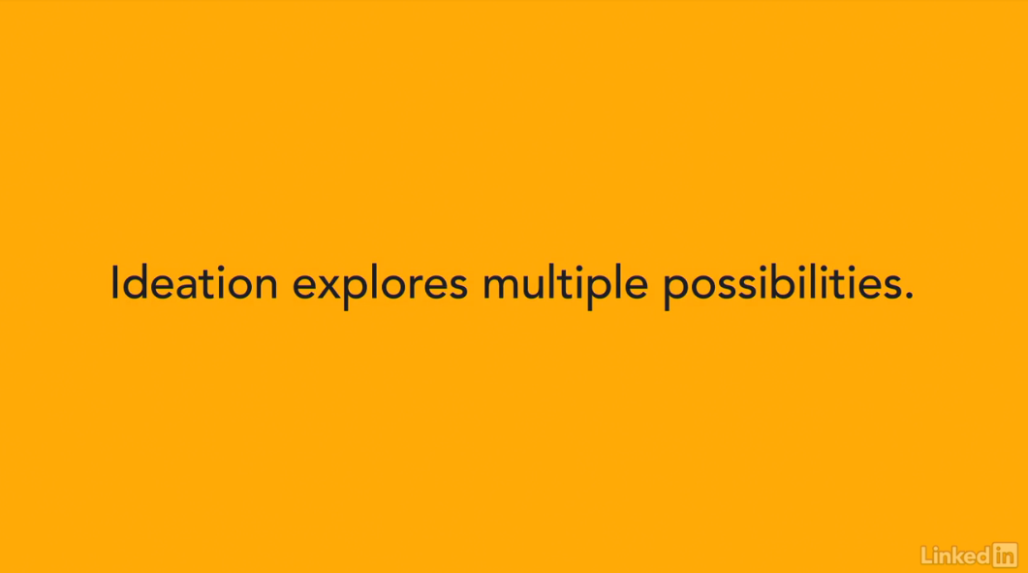

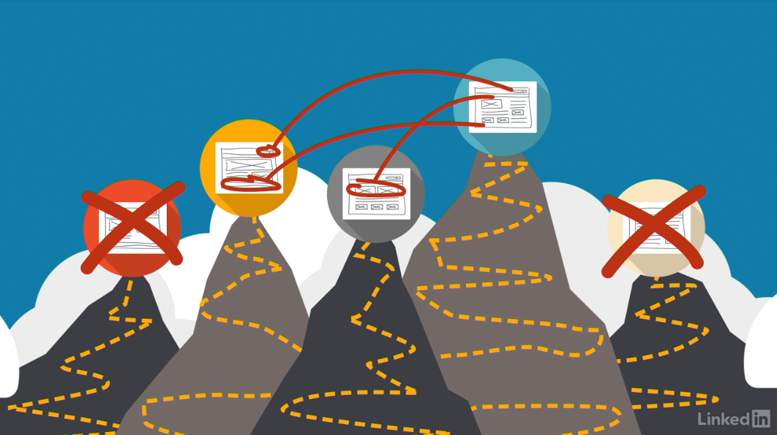

[So, why would you want to create a whole set of ideas when, ultimately, you'll only going to be using one of them? You do this to avoid falling into the local maximum trap. The local maximum is a way of describing your ability to design the best possible product. Imagine that you're exploring a new area. You're trying to climb up the highest hill, but while you're climbing up a hill, you don't know how tall it's going to be. It's not until you've explored several different hills that you can work out which is the tallest. Now, imagine that the hills in this description are actually different designs that you could use. You don't know which is the best design, the one at the top of the tallest hill, until you've explored several different hills. It doesn't make sense to just keep climbing up the hill that you're on right now, because who knows whether there's a taller hill, that is, a better design, until you've explored several different alternatives. And that's what ideation does. It avoids the local maximum trap by helping you explore several alternative designs before you get too engrossed in any one way of doing things. Rather than just following one single track, you take a short period of time to explore multiple possibilities. Some may end up not being possible, others may not seem too useful, but a few will give you new ideas that you can integrate into your design process in order to create the best possible solution for your user's needs.](https://www.linkedin.com/learning/ux-design-4-ideation/the-local-maximum-problem?autoSkip=true&resume=false)

**The benefits of ideation techniques**

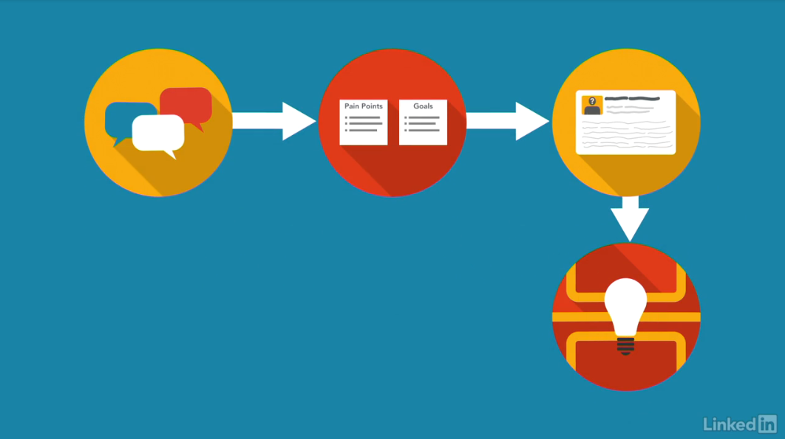

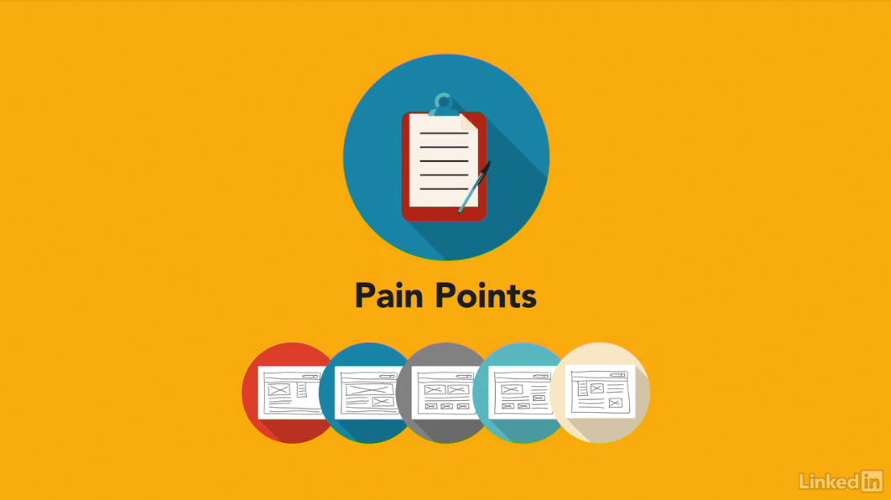

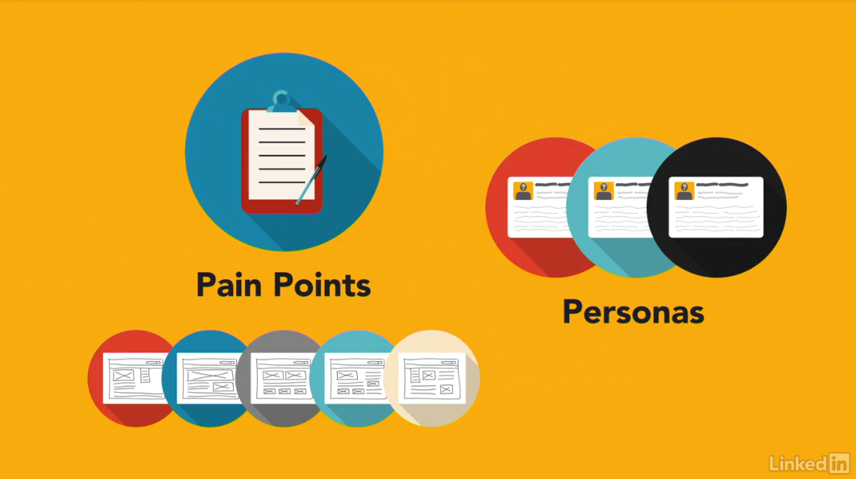

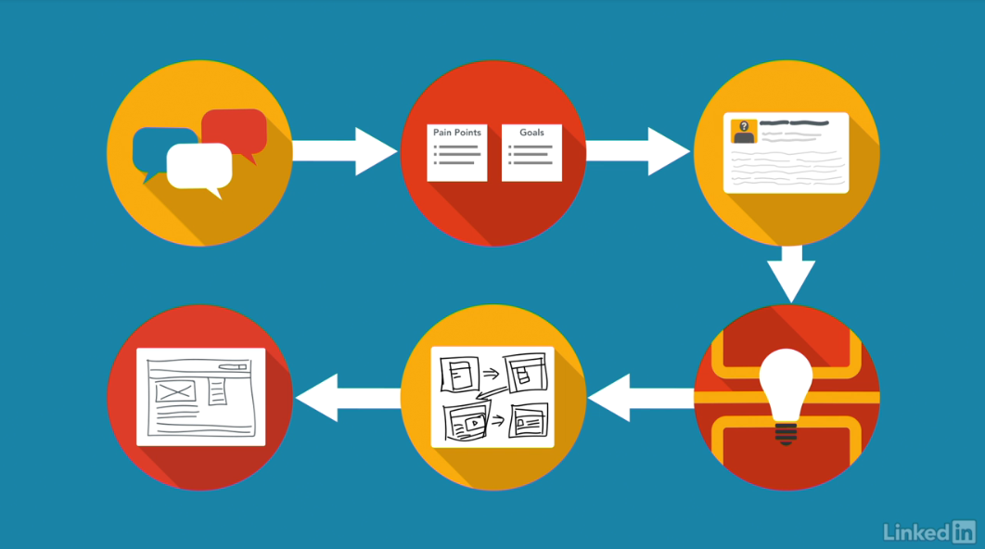

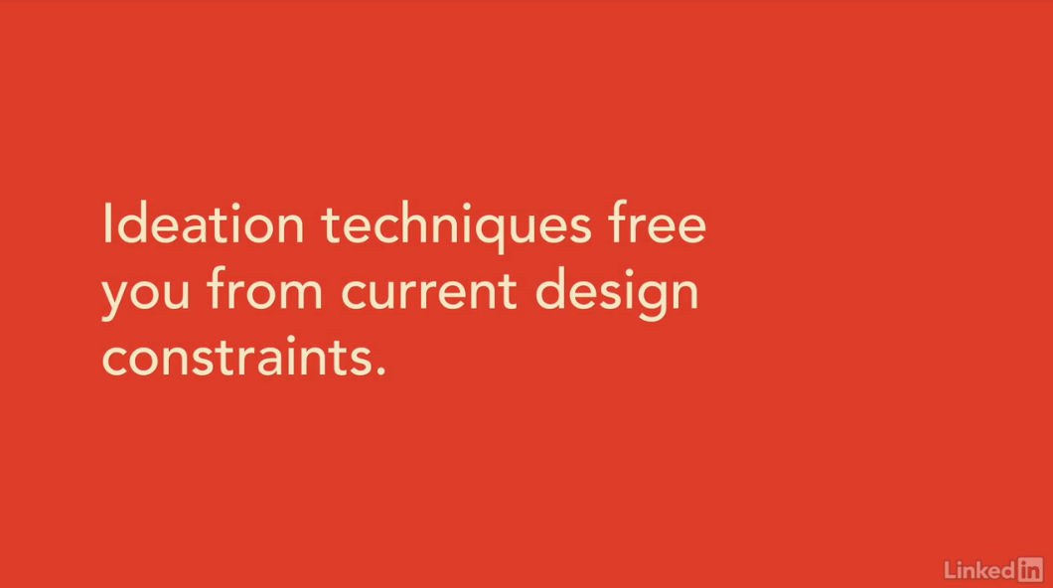

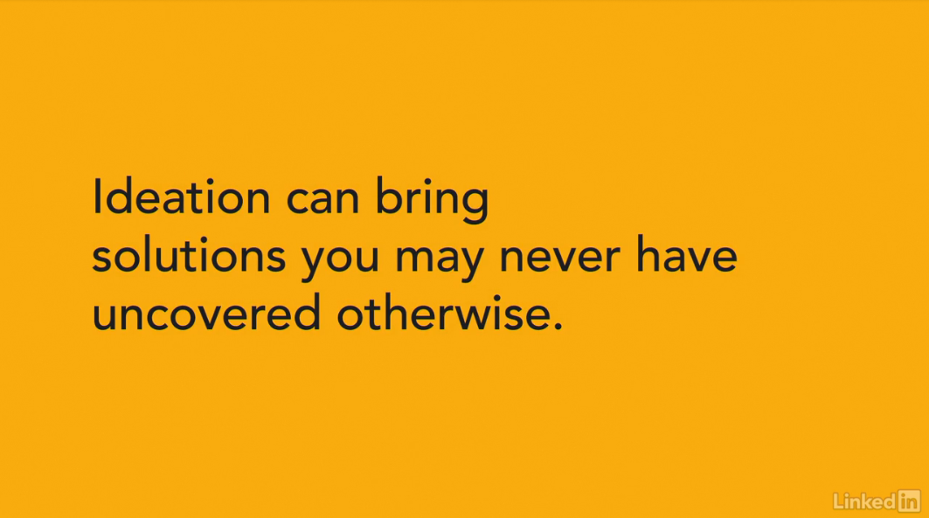

[Ideation fits into the user-centered design process right after you've discovered your user's pain points and decided upon your personas.](https://www.linkedin.com/learning/ux-design-4-ideation/the-benefits-of-ideation-techniques?resume=false)

[Ideation techniques allow you to generate multiple potential solutions to the pain points you uncovered.](https://www.linkedin.com/learning/ux-design-4-ideation/the-benefits-of-ideation-techniques?resume=false)

[The information that you need to do the ideation work comes from your experience map, and the list of pain points and goals you created. Obviously, you need some focus for the ideation process, and that's where your personas help, by providing a reality check.](https://www.linkedin.com/learning/ux-design-4-ideation/the-benefits-of-ideation-techniques?resume=false)

[After doing an ideation exercise to discover multiple possible paths, you'll narrow your focus and bring things back to reality somewhat by creating scenarios and storyboards.](https://www.linkedin.com/learning/ux-design-4-ideation/the-benefits-of-ideation-techniques?resume=false)

[These tools describe the design ideas that you've chosen to follow as a result of the ideation exercise. They turn the abstract design ideas into specific, understandable, actionable items.](https://www.linkedin.com/learning/ux-design-4-ideation/the-benefits-of-ideation-techniques?resume=false)

[By showing how the ideation concept would apply to your personas, creating a day-in-the-life story of the persona's interaction with the new design concepts. After you have your scenarios and storyboards you can create a prototype user interface to test out those ideas, and refine them, before committing anything to code.](https://www.linkedin.com/learning/ux-design-4-ideation/the-benefits-of-ideation-techniques?resume=false)

[In this way, you save time and money by working out what you plan on building early in the process, before it gets costly to make changes.](https://www.linkedin.com/learning/ux-design-4-ideation/the-benefits-of-ideation-techniques?resume=false)

[Ideation techniques free you from your current design constraints.](https://www.linkedin.com/learning/ux-design-4-ideation/the-benefits-of-ideation-techniques?resume=false)

[Rather than trying to just add new pieces onto your current interface, the equivalent of trying to climb the same hill, you'll explore some alternatives that might just take you in a new direction that let's you climb a taller hill and create a design that better suits your user's needs.](https://www.linkedin.com/learning/ux-design-4-ideation/the-benefits-of-ideation-techniques?resume=false)

[Ideation involves the whole team, in generating multiple different alternative design ideas and allows you to perform a design reset so that you can assess different alternatives and set off on a path that's more likely to meet your user-centered design goals.](https://www.linkedin.com/learning/ux-design-4-ideation/the-benefits-of-ideation-techniques?resume=false)

[It's amazing how creative different team members can be when you give them the opportunity.](https://www.linkedin.com/learning/ux-design-4-ideation/the-benefits-of-ideation-techniques?resume=false)

[Ideation exercises are an opportunity to draw that creativity out. Let everyone on the team feel like they've contributed to the solution that you decide to go with.](https://www.linkedin.com/learning/ux-design-4-ideation/the-benefits-of-ideation-techniques?resume=false)

[The benefit of this type of exercise should be obvious. You inject new ideas into your design process and the creativity you unleash on the team leads to solutions you may never have uncovered otherwise.](https://www.linkedin.com/learning/ux-design-4-ideation/the-benefits-of-ideation-techniques?resume=false)